Constructing Rhombus

Definition
# Source: AI Source: Provided by: [Data Path: Persons Table -> ID Column: 1, Name_En Column: Motasem Essam] -> From: [ChatGPT] on [7/25/2026]
Constructing a Rhombus is the geometric construction of a quadrilateral with four equal sides, using classical geometric tools such as a straightedge and compass.
A rhombus $ABCD$satisfies:
$$\boxed{AB=BC=CD=DA}$$
Since a rhombus is a parallelogram, its opposite sides are also parallel:
$$\boxed{AB∥CD} \\ \boxed{AD∥BC}$$
Its angles are not necessarily right angles.

Fundamental Concept
# Source: AI Source: Provided by: [Data Path: Persons Table -> ID Column: 1, Name_En Column: Motasem Essam] -> From: [ChatGPT] on [7/25/2026]
A rhombus can be constructed from different types of given information, such as:
- one side and an included angle
- two diagonals
- one side and one diagonal
- three vertices
- a side length and an angle
The most fundamental construction is a rhombus from a given side and included angle.
Suppose:
$$AB=s$$
and:
$$∠DAB=θ$$
The goal is to construct $ABCD$such that:
$$AB=BC=CD=DA=s$$
and:
$$AB∥CD, AD∥BC$$

Main Construction: Rhombus from a Given Side and Angle
# Source: AI Source: Provided by: [Data Path: Persons Table -> ID Column: 1, Name_En Column: Motasem Essam] -> From: [ChatGPT] on [7/25/2026]
Suppose $AB$is the given side and $∠DAB$is the given angle.
Steps
- Construct the given segment:
$$AB=s$$
- At $A$, construct the given angle:
$$∠DAB=θ$$
- On the second ray, mark $D$such that:
$$AD=AB=s$$
- With center $B$and radius $s$, draw an arc.
- With center $D$and radius $s$, draw another arc.
- Let the appropriate intersection be $C$.
- Connect:
$$B-C$$
and:
$$C-D$$
- The resulting quadrilateral $ABCD$is a rhombus.
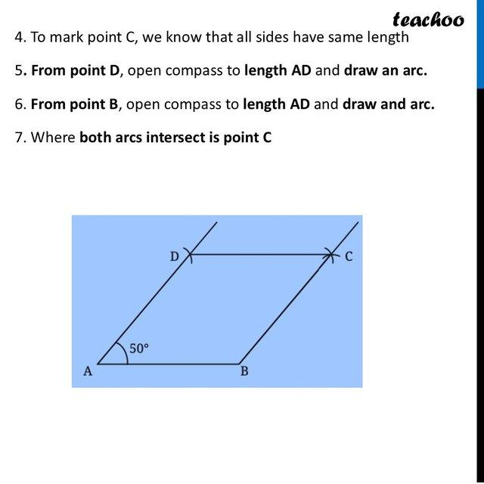
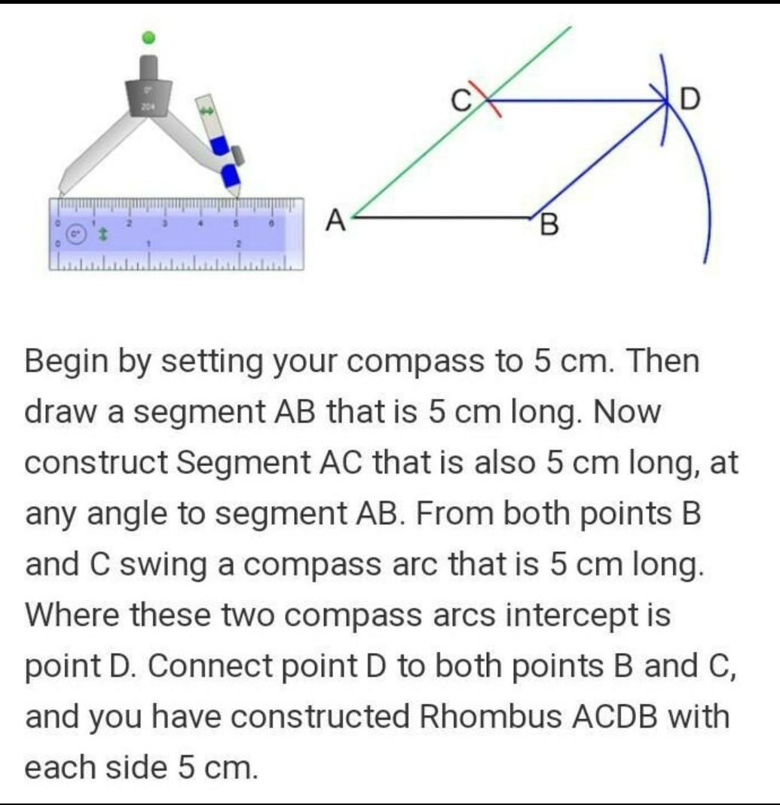
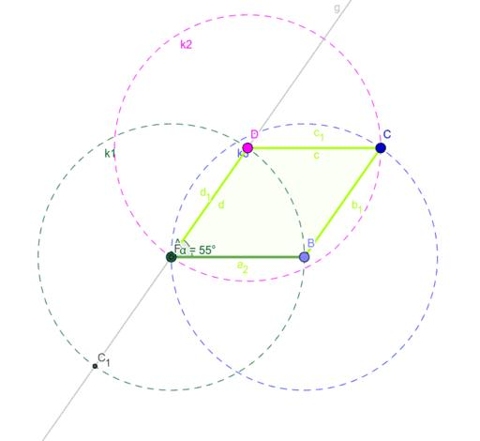
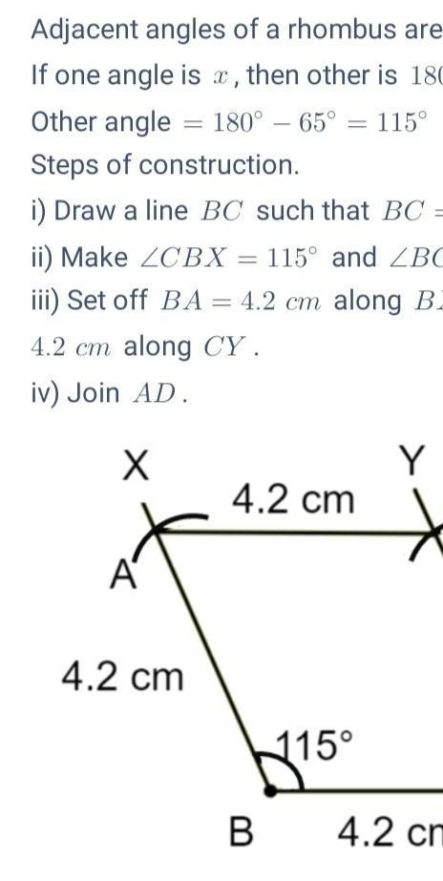
Result
$$\boxed{AB=BC=CD=DA=s}$$
Therefore:
$$\boxed{ABCD\text{ is a rhombus}}$$

Why the Construction Works
# Source: AI Source: Provided by: [Data Path: Persons Table -> ID Column: 1, Name_En Column: Motasem Essam] -> From: [ChatGPT] on [7/25/2026]
The first two sides are constructed so that:
$$AB=AD=s$$
Then the arcs centered at $B$and $D$both have radius $s$.
Therefore, for their intersection $C$:
$$BC=s$$
and:
$$DC=s$$
Thus:
$$AB=BC=CD=DA$$
Therefore the quadrilateral has four equal sides and is a rhombus.

Constructing a Rhombus from Two Diagonals
# Source: AI Source: Provided by: [Data Path: Persons Table -> ID Column: 1, Name_En Column: Motasem Essam] -> From: [ChatGPT] on [7/25/2026]
A rhombus can also be constructed when the lengths of its two diagonals are given.
Let the diagonals be:
$$AC=d_{1}$$
and:
$$BD=d_{2}$$
A fundamental property of a rhombus is that its diagonals:
- bisect each other
- are perpendicular
Steps
- Construct diagonal $AC$.
- Construct its midpoint $O$.
- Through $O$, construct a perpendicular line to $AC$.
- On this perpendicular, mark $B$and $D$such that:
$$OB=OD=\frac{d_{2}}{2}$$
- Connect:
$$A-B-C-D-A$$
- The resulting quadrilateral is a rhombus.
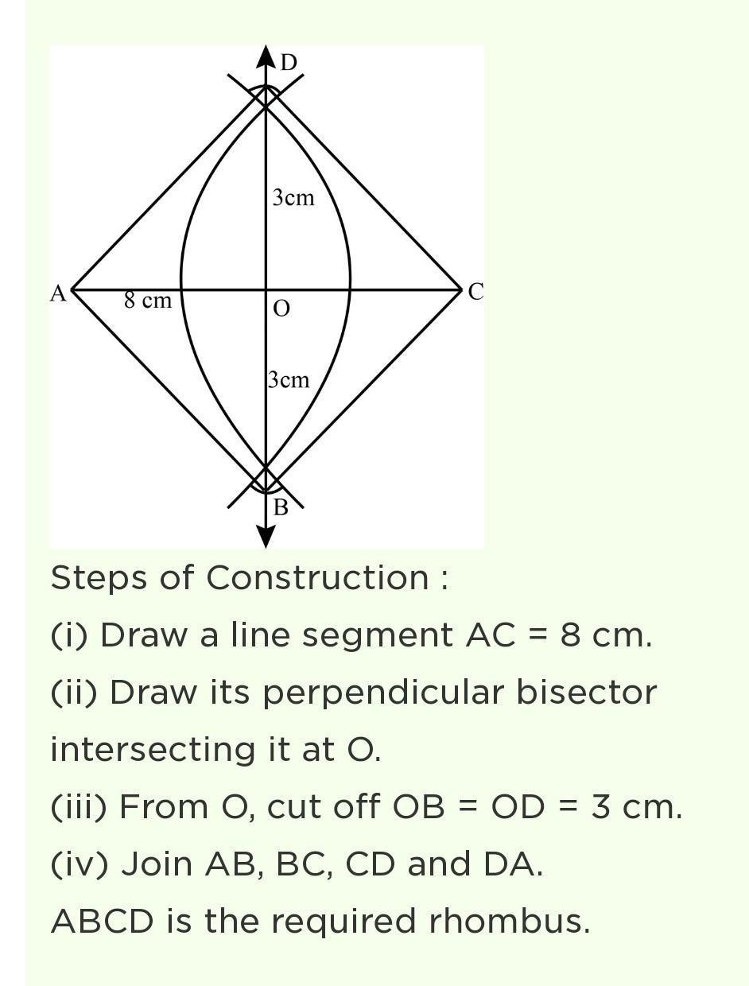
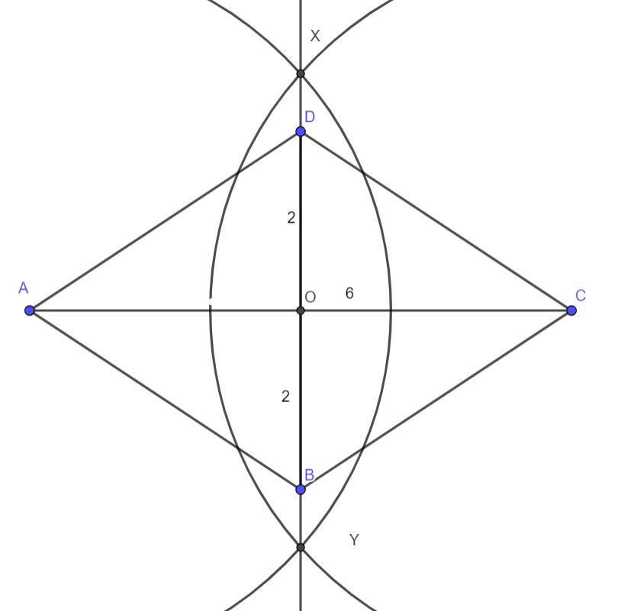
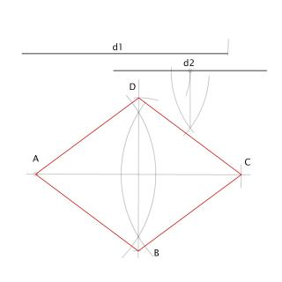
The construction uses:
$$\boxed{AC⊥BD}$$
and:
$$\boxed{AO=OC} \\ \boxed{BO=OD}$$

Constructing a Rhombus from One Side and One Diagonal
# Source: AI Source: Provided by: [Data Path: Persons Table -> ID Column: 1, Name_En Column: Motasem Essam] -> From: [ChatGPT] on [7/25/2026]
Suppose side $AB$and diagonal $AC$are given.
Steps
- Construct:
$$AB=s$$
- Set the compass to the given diagonal length $AC=d$.
- With center $A$, draw an arc.
- With center $B$and radius $s$, draw another arc.
- Locate $C$from the appropriate intersection.
- Use the rhombus properties to construct the remaining vertex $D$.
- Connect all four vertices.
An alternative method is to use the fact that a rhombus diagonal bisects the vertex angles and then construct the appropriate reflected vertex.
The construction is possible only when the given dimensions satisfy the required geometric conditions.

Constructing a Rhombus from Three Vertices
# Source: AI Source: Provided by: [Data Path: Persons Table -> ID Column: 1, Name_En Column: Motasem Essam] -> From: [ChatGPT] on [7/25/2026]
If three consecutive vertices $A$, $B$, and $C$are given and:
$$AB=BC$$
then the fourth vertex $D$can be constructed by completing the parallelogram.
Steps
- Draw $AB$and $BC$.
- Through $A$, construct a line parallel to $BC$.
- Through $C$, construct a line parallel to $AB$.
- Let their intersection be $D$.
- Connect the vertices.
Because:
$$AB=BC$$
and opposite sides of a parallelogram are equal:
$$AB=CD \\ BC=AD$$
Therefore:
$$\boxed{AB=BC=CD=DA}$$
and $ABCD$is a rhombus.

Properties of a Constructed Rhombus
# Source: AI Source: Provided by: [Data Path: Persons Table -> ID Column: 1, Name_En Column: Motasem Essam] -> From: [ChatGPT] on [7/25/2026]
For rhombus $ABCD$:
Four Equal Sides
$$\boxed{AB=BC=CD=DA}$$
Opposite Sides Are Parallel
$$\boxed{AB∥CD} \\ \boxed{AD∥BC}$$
Opposite Angles Are Equal
$$\boxed{∠A=∠C} \\ \boxed{∠B=∠D}$$
Consecutive Angles Are Supplementary
$$\boxed{∠A+∠B={180}^{∘}}$$
Diagonals Bisect Each Other
If the diagonals intersect at $O$:
$$\boxed{AO=OC} \\ \boxed{BO=OD}$$
Diagonals Are Perpendicular
$$\boxed{AC⊥BD}$$
Diagonals Bisect the Angles
Each diagonal of a rhombus bisects a pair of opposite angles.
For example:
$$\boxed{∠BAC=∠CAD}$$
and:
$$\boxed{∠BCA=∠ACD}$$

Formulas Related to Construction
# Source: AI Source: Provided by: [Data Path: Persons Table -> ID Column: 1, Name_En Column: Motasem Essam] -> From: [ChatGPT] on [7/25/2026]
If the side length is $s$:
Perimeter
$$\boxed{P=4s}$$
Area from Base and Height
$$\boxed{A=sh}$$
Area from Diagonals
If the diagonals are $d_{1}$and $d_{2}$:
$$\boxed{A=\frac{d_{1}d_{2}}{2}}$$
Relationship Between Side and Diagonals
Since the diagonals bisect each other at right angles:
$${\left(\frac{d_{1}}{2}\right)}^{2}+{\left(\frac{d_{2}}{2}\right)}^{2}=s^{2}$$
Therefore:
$$\boxed{d_{1}^{2}+d_{2}^{2}=4s^{2}}$$

Types of Rhombus Construction
# Source: AI Source: Provided by: [Data Path: Persons Table -> ID Column: 1, Name_En Column: Motasem Essam] -> From: [ChatGPT] on [7/25/2026]
These are primarily construction situations, rather than different mathematical types of rhombi.
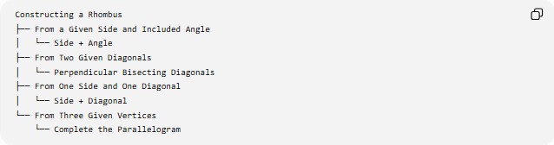
Constructing a Rhombus
├── From a Given Side and Included Angle
│ └── Side + Angle
├── From Two Given Diagonals
│ └── Perpendicular Bisecting Diagonals
├── From One Side and One Diagonal
│ └── Side + Diagonal
└── From Three Given Vertices
└── Complete the Parallelogram

Construction Classification
# Source: AI Source: Provided by: [Data Path: Persons Table -> ID Column: 1, Name_En Column: Motasem Essam] -> From: [ChatGPT] on [7/25/2026]
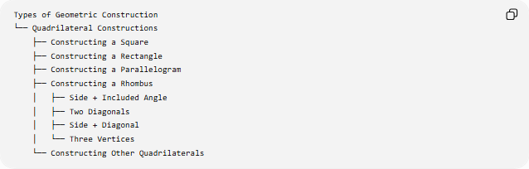
Types of Geometric Construction
└── Quadrilateral Constructions
├── Constructing a Square
├── Constructing a Rectangle
├── Constructing a Parallelogram
├── Constructing a Rhombus
│ ├── Side + Included Angle
│ ├── Two Diagonals
│ ├── Side + Diagonal
│ └── Three Vertices
└── Constructing Other Quadrilaterals
A more detailed structure is:
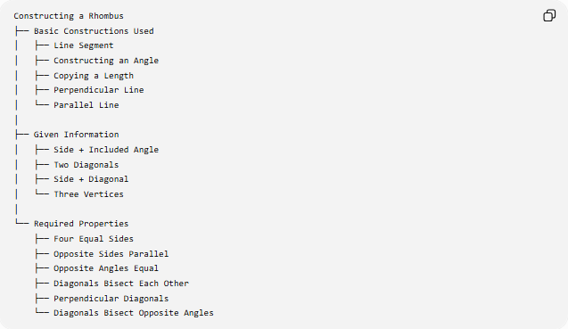
Constructing a Rhombus
├── Basic Constructions Used
│ ├── Line Segment
│ ├── Constructing an Angle
│ ├── Copying a Length
│ ├── Perpendicular Line
│ └── Parallel Line
│
├── Given Information
│ ├── Side + Included Angle
│ ├── Two Diagonals
│ ├── Side + Diagonal
│ └── Three Vertices
│
└── Required Properties
├── Four Equal Sides
├── Opposite Sides Parallel
├── Opposite Angles Equal
├── Diagonals Bisect Each Other
├── Perpendicular Diagonals
└── Diagonals Bisect Opposite Angles

Rhombus and Other Quadrilateral Constructions
# Source: AI Source: Provided by: [Data Path: Persons Table -> ID Column: 1, Name_En Column: Motasem Essam] -> From: [ChatGPT] on [7/25/2026]
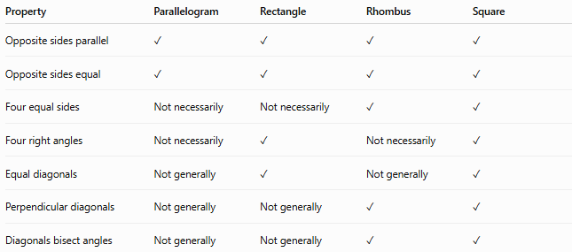
Property | Parallelogram | Rectangle | Rhombus | Square
Opposite sides parallel | ✓ | ✓ | ✓ | ✓
Opposite sides equal | ✓ | ✓ | ✓ | ✓
Four equal sides | Not necessarily | Not necessarily | ✓ | ✓
Four right angles | Not necessarily | ✓ | Not necessarily | ✓
Equal diagonals | Not generally | ✓ | Not generally | ✓
Perpendicular diagonals | Not generally | Not generally | ✓ | ✓
Diagonals bisect angles | Not generally | Not generally | ✓ | ✓
A rhombus is a special type of parallelogram:
$$\boxed{\text{Rhombus}⊂\text{Parallelogram}}$$
A square is a special rhombus:
$$\boxed{\text{Square}⊂\text{Rhombus}}$$
because a square has four equal sides in addition to four right angles.

Example
# Source: AI Source: Provided by: [Data Path: Persons Table -> ID Column: 1, Name_En Column: Motasem Essam] -> From: [ChatGPT] on [7/25/2026]
Construct a rhombus with:
$$AB=6\text{ cm}$$
and:
$$∠DAB={60}^{∘}$$
Construction
- Construct:
$$AB=6\text{ cm}$$
- At $A$, construct:
$$∠DAB={60}^{∘}$$
- On the second ray, mark:
$$AD=6\text{ cm}$$
- With centers $B$and $D$, draw arcs of radius $6$cm.
- Let their intersection be $C$.
- Connect $B-C$and $C-D$.
Therefore:
$$\boxed{AB=BC=CD=DA=6\text{ cm}}$$
The perimeter is:
$$P=4\left(6\right) \\ \boxed{P=24\text{ cm}}$$
Since the included angle is ${60}^{∘}$, the rhombus is actually a rhombus with all angles ${60}^{∘},{120}^{∘}$, not a square.
Its area is:
$$A=s^{2}\sin{θ}$$
so:
$$A=6^{2}\sin{{60}^{∘}} \\ A=36⋅\frac{\sqrt{3}}{2} \\ \boxed{A=18\sqrt{3}{\text{ cm}}^{2}}$$

Tools Used
# Source: AI Source: Provided by: [Data Path: Persons Table -> ID Column: 1, Name_En Column: Motasem Essam] -> From: [ChatGPT] on [7/25/2026]
Straightedge
Used to:
- draw sides
- connect vertices
- construct parallel lines
- construct auxiliary lines
Compass
Used to:
- transfer side lengths
- construct equal distances
- construct arcs
- locate vertices
Therefore:
$$\boxed{\text{Classical Rhombus Construction}=\text{Straightedge + Compass}}$$

Key Points
# Source: AI Source: Provided by: [Data Path: Persons Table -> ID Column: 1, Name_En Column: Motasem Essam] -> From: [ChatGPT] on [7/25/2026]
- A rhombus has four equal sides.
- A rhombus is a parallelogram.
- Opposite sides are parallel.
- Opposite angles are equal.
- Consecutive angles are supplementary.
- The diagonals bisect each other.
- The diagonals are perpendicular.
- The diagonals bisect the opposite angles.
- A rhombus can be constructed from a side and included angle.
- It can also be constructed from two diagonals.
- Its perimeter is:
$$P=4s$$
- Its area can be calculated by:
$$A=sh$$
or:
$$A=\frac{d_{1}d_{2}}{2}$$
- A square is a special rhombus in which all four angles are ${90}^{∘}$.

Conclusion
# Source: AI Source: Provided by: [Data Path: Persons Table -> ID Column: 1, Name_En Column: Motasem Essam] -> From: [ChatGPT] on [7/25/2026]
Constructing a Rhombus is the geometric construction of a quadrilateral with four equal sides. The construction can use a given side and angle, two diagonals, a side and diagonal, or three vertices. Its defining properties are four equal sides and two pairs of parallel opposite sides, while its diagonals bisect each other perpendicularly and bisect the opposite angles. The construction combines fundamental techniques such as constructing segments, copying lengths, constructing angles, perpendiculars, and parallel lines.

